Elder Norms

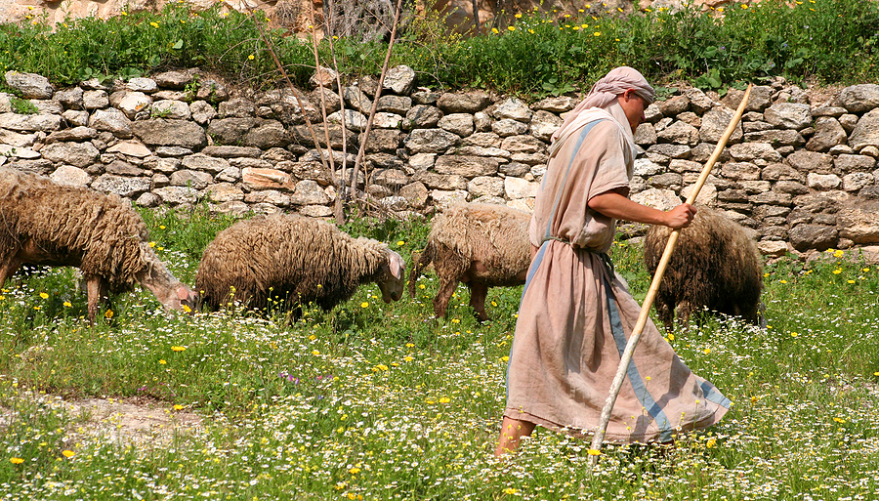

“Group rules” or norms are “the way we do things in our group.” Often, they are unconscious, rarely discussed, seldom decided deliberately, and often contradictory. Different people come from different families and those families have different rules. When people come together in a group, the different family rules may conflict. Family rules often become more important than the Bible – even in strong Christian groups. These norms are often elevated to God’s truth. They are not just the “way we did things in our family,” but that is the way things “ought to be done.”
Think about this eldership. How would you like to function as an eldership? What does the Bible say? What guidelines would you like to have to carry out the work given to you by the Holy Spirit in the Bible?

● THE FUNCTION OF ELDERS RULES
What is our understanding, as a group, about the work of elders?

What is the difference in the work of elders and deacons?

How do our meetings and time spent in elder work reflect that?

● SHEPHERDING RULES
What are our rules for getting to know the sheep?

How do we care for the sheep?

How do we protect the sheep?

How do we guide the sheep into green pastures and still waters?

How do we shepherd each other? What is our plan to know each other, rejoice with each other, weep with each other, and care for each other?

● DEACON RULES
How much authority and responsibility are given to deacons?

How does this eldership handle the accountability of deacons? What happens when deacons don’t deak?

How are deacons rewarded and encouraged for work well done?

● OVERSEEING RULES
How do we oversee, manage the congregation?

Do we oversee the congregation as a group of elders or do individual elders manage specific areas of the work of this congregation?

● MINUTES RULES
Who keeps minutes of the meetings?

How do you share the approved minutes?

What happens when you have a disagreement about what your discussion and decision was?

● LEADERSHIP
Who is the leader of our meetings?

Is it the same person each time?

Is the leadership rotated? If so, how is leadership rotated and how often?

● QUORUM
How many in the group must be present to make an “official” decision?

● DECISIONS
How does the group arrive at a group decision or a group solution to a problem?
Majority
Minority
The first to speak
The last to speak
The oldest
The youngest
Other

● ABSENCES
When a person is going to be absent, how does the group learn this?

● NUMBER SPEAKING
How many speak at a time in meetings?

Does the group permit whispering and private conversations that the entire group cannot hear?

● REPRESENTATION
When I speak in a meeting, for whom am I speaking?
Myself
Myself and God
Myself and my family
Myself and a specified group
Myself and “a bunch of others”
Other

● DISAGREEMENT
Do we have a right to disagree with each other in our discussions?

When we disagree with each other in group meetings, do we speak with one voice to the congregation?

Who finds out about our disagreements?

● CONFIDENTIALITY
To whom do I speak about what is discussed and what is done in our meetings?
Any and everyone
My wife
My wife and a few trusted friends
One or two trusted friends
No one

If I speak to someone else about what goes on in our meetings, to whom do I expect that person to share the information?
Any and everyone
His or her spouse
His or her spouse and a few trusted friends
One or two trusted friends
No one

How do I get that agreement?

● CONFLICT
How do we handle conflict?

What is considered “arguing fair?”

What is considered “not arguing fair?”

With whom can I disagree?

With whom can I not disagree?

What topics cannot be discussed?

● FEELINGS – SADNESS, JOY, FEAR, ANGER
What feelings are acceptable to have and to express?

What feelings are unacceptable and are not to be discussed?

● WORKING WITH STAFF
How do you view staff?
Team members that can listen, learn, teach, contribute—trained professionals who
participate in thinking and planning for the church.
Hired help that need to be supervised, watched, controlled—giving and
withholding permission for requests.

How is that reflected by when you meet with them and what you do when you meet with them?

● TRANSITION RULES
What agreements do we have for smooth transitions when elders, deacons, and other leaders need to resign or move?

● APPRECIATION RULES
What policies and practices do we have to express gratitude to people when they are serving well and to show appreciation when they resign?

● EMAIL, MESSAGE RULES
What communication will we be doing by email, message: factual (meeting
places, times), decisions, conflict?
Who will compose and send elder emails, messages?
Who will read elder emails, messages (wife, children)?
Who will have access to elder’s emails?

● OTHER RULES
What other rules does our group have?

● RULE VIOLATIONS
How do we deal with rule violations?
Ignore them
Learn from them

● CHANGE OF RULES
Have we ever changed our rules?

What was the occasion for the change and how was it done?

How often will we evaluate our rules?

